**Project: AHI Real-Time Marketing Analytics App**

**Burndown Chart Analysis**

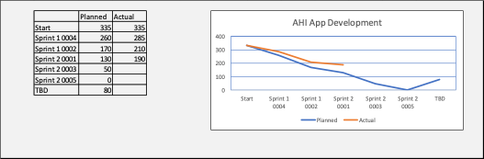

**Question 1: What problems does the burndown chart show about the project?**

1. The team is using more hours than planned.
2. Some sprints are falling behind schedule.
3. Work is not decreasing steadily.
4. Extra work (TBD) was added late.
5. Progress is inconsistent across sprints.

**Question 2: What changes could the team make to improve the chances of meeting the project scope and schedule?**

1. Add a trained Scrum Master to guide the team.
2. Lock user stories before the sprint starts.
3. Review and refine backlog regularly.
4. Avoid big changes during a sprint.
5. Confirm needs with stakeholders early.

**Question 3: What changes could the team have made earlier to be more successful?**

1. Get clear user requirements at the start.
2. Train the team on how Scrum works.
3. Let the team plan their own tasks.
4. Include all work in the original backlog.
5. Use shorter sprints to stay on track.